**PRACTICAL No.1**

**AIM: Write a Program to read one integer number and print the value of enterednumber.**

**STEPS:**

num=input("Enter a number: ")

print("Entered number is:" +num)

________________________________________________________________________________________________________________________________________________________________________________________________________________________________________________________________________________________________________________________________________________________________________________________________________________________________________________________________________________________________________________________________________________________________________________________________________________________________________________________________________________________________________________________________________________________________________________________________________________________________________________________________________________________________________________________________________________________________________________________

**SCREENSHOT:**

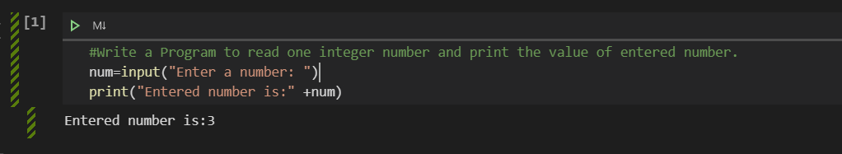

**Date:**